**Objectives**

1. **Research information about software for a specific operating system (OS) environment. You will be assigned one of the operating systems form the list below. You will also be provided with a list of topics to investigate.**
2. **Organize your rough research information into a list of topics, sub-topics and facts. This process will involve identifying sub-topics, rearranging your rough research notes, and selecting (or highlighting) interesting facts.**
3. **Report a summary of your research in the form of a “concept map”. Use the PowerPoint template provided as a starting point. The concept map should only include the best and most interesting information from your organized research notes.**
4. **Your concept map can be created using: Smart Ideas, Prezi, PowerPoint or other similar applications.**

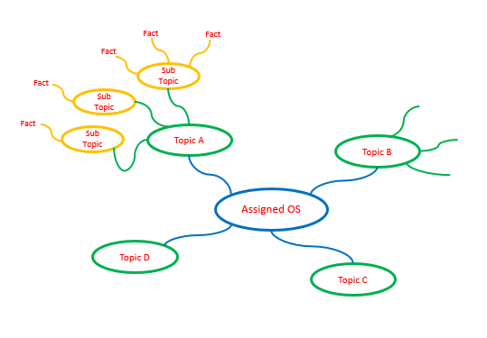

**Step 1 – Organized Research**

**Research information about your assigned operating system (OS) environment.**

* **Guide your research according to the suggested topic list below**
* **Feel free to copy-and-paste as long as you keep track of your bibliographic references.**
* **Do not be too picky or concerned about formatting as you will organize this information later in step 2**
* **Select things that look interesting and don’t forget to include graphics images as well**
* **Upload your rough research notes to your repository when you are done.**

**Topic A – Application Software**

**Provide a summary of most important user application software targeted by this operating system and how it is similar to and deferent from standard PC software. Suggested sub-topics include:**

* **User (client) or network (server) applications**
* **Batch (run without user input) or interactive (user focused) processing**
* **Off-the-shelf (purchased) or custom developed applications**
* **Programming environment and languages supported**

[**https://linuxhint.com/check_memory_usage_process_linux/**](https://linuxhint.com/check_memory_usage_process_linux/)

**Topic B – Hardware**

**Provide a summary of the hardware targeted by this operating system and how it is similar to and deferent from standard PC hardware. Suggested sub-topics include:**

* **Speed of processors / memory**
* **Capacity of memory / attached disks**
* **Is it designed for home / office / corporate data center / industrial use**
* **Is it designed for client / server / network use**

[**https://www.fossmint.com/speed-up-ubuntu-linux/**](https://www.fossmint.com/speed-up-ubuntu-linux/)

**Topic C – User Interface**

**Provide a summary of the user interface and input devices targeted by this operating system and how it is similar to and deferent from a standard PC. Suggested sub-topics include:**

* **Does it support a windowed environment, command line, or network users**
* **Does it support multiple users at a time or single users**
* **Does it support multiple applications or a single application at a time**
* **Does it get rebooted (powered on / off) or is it always on**

[**https://opensource.com/resources/linux**](https://opensource.com/resources/linux)

**Topic D – Device Management**

**Provide a summary of the devices (disks, printers, etc.) and memory managed by this operating system and how it is similar to and deferent from a standard PC. Suggested sub-topics include:**

* **What types of disk drives and file systems does it support**
* **What type of input devices does it support**
* **What type of output devices does it support**

[**https://www.binarytides.com/linux-command-check-disk-partitions/**](https://www.binarytides.com/linux-command-check-disk-partitions/)

**Topic E – Security**

**Provide a summary of the security features provided by this operating system and how it is similar to and deferent from a standard PC. Suggested sub-topics include:**

* **What types of user accounts and user permissions does it support**
* **How does it protect against conflicts / interference between legitimate application processes**
* **How does it protect against malicious software**
* **How does it support software updates and security updates**

[**https://www.howtogeek.com/366699/what-can-you-actually-run-on-linux/**](https://www.howtogeek.com/366699/what-can-you-actually-run-on-linux/)

**Topic F – Network Connectivity**

**Provide a summary of the network connectivity provided by this operating system and how it is similar to and deferent from a standard PC. Suggested sub-topics include:**

* **Is the computer stand-alone or part of a larger network**
* **What type of network and internet connections does it provide**
* **Does it provide other services such as backup, firewall, etc.**

[**https://geekflare.com/linux-test-network-connectivity/**](https://geekflare.com/linux-test-network-connectivity/)

**Step 2 – Concept Map**

**Create a “concept map” as a final report of your organized research.**

* **Use the diagram in the introduction as a starting point.**
* **You should have six (6) first level topics from “Application Software”   
  to “Network Connectivity”**
* **Each first level topic should have at least three (3) sub-topics**
* **Each sub-topic should be supported by a number of facts / items of interest**

**Select the best and most interesting information from your organized research.**

* **Summarize and edit your information to fit on the concept map.**

**Upload your Research Notes and Concept Map to your GitHub Repository**

* **Your concept map can be created using: Smart Ideas, Prezi, PowerPoint or other   
  similar applications.**
* **Option1: Create and upload a PDF of your concept map**
* **Option2: Include a link to your Concept Map in your Student Questions**
  + **Make sure that your link is Sharable so Mr. Nestor can open your map**

**Appendix A**

|  |  |  |
| --- | --- | --- |
| **Operating System** | **Student 1** | **Student 2** |
| **Ubuntu  (Linux)** |  |  |
| **z/OS  (IBM)** |  |  |
| **Solaris  (Oracle)** |  |  |
| **HP-UX  (Hewlett Packard)** |  |  |
| **Windows NT  (Windows Server)** |  |  |
| **Red Hat Enterprise (IBM Summit)** |  |  |
| **QNX  (Blackberry)** |  |  |
| **VxWorks  (Wind River)** |  |  |
| **AOSP  (Android Alphabet)** |  |  |
| **Ubuntu  (Linux)** |  |  |
| **z/OS  (IBM)** |  |  |
| **Solaris  (Oracle)** |  |  |
| **HP-UX  (Hewlett Packard)** |  |  |
| **Windows NT  (Windows Server)** |  |  |
| **Red Hat Enterprise (IBM Summit)** |  |  |
| **QNX  (Blackberry)** |  |  |
| **VxWorks  (Wind River)** |  |  |
| **AOSP  (Android Alphabet)** |  |  |
|  |  |  |
|  |  |  |
|  |  |  |
|  |  |  |